16.1: a)
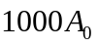Therefore, the amplitude is 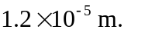 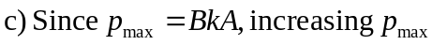 while keeping A constant requires decreasing k, and increasing , by the same factor. Therefore the new wavelength is

